Calculating the area of the cranberry fruit by image J

**I. Preparing sheets to be scan**

1. Collect the sheets with the cranberry stamps. Keep track of the order of this sheets in the binder. It is important to put the sheets back where you found them.
2. Verify that the stamps are complete. Meaning, there is no white spaces from the flesh of the cranberry. If so, please **carefully** fill them out. The only white spaces that you should notice are the 4 inner locules of the cranberry stamp.

test cran-001.tif 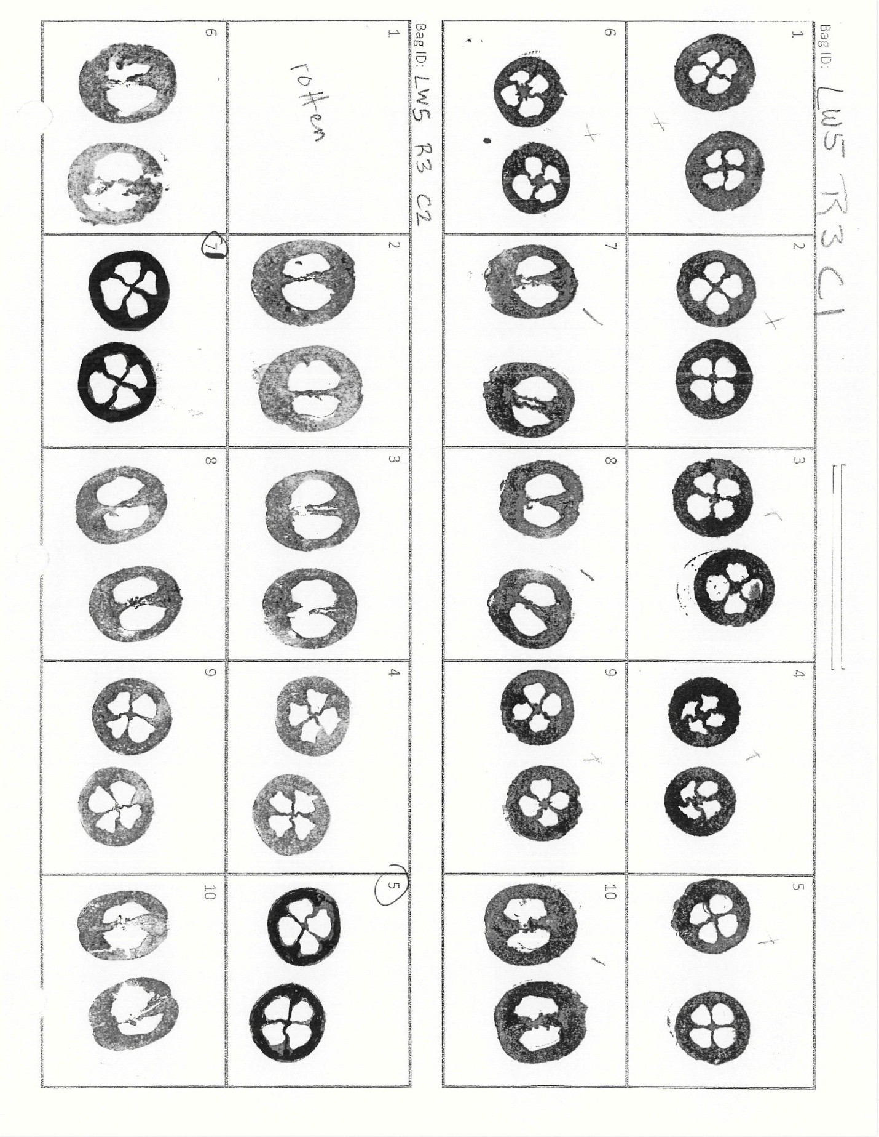  
Stamp with white spaces 🡪 Fill those spaces with a black sharpie fine point   
in the flesh

**II. Scanning the files**

1. Have an USB handy.
2. Log in in the copy machine of Hort Department (3rd floor) (login number: 29650). Click Ok in the digital screen.
3. Install the USB unit. You can find the port at the right side , close to the big and round button.
4. Select option image send

----- take instructions from the copy machine

**II Convert PDF files to JPG**

1. 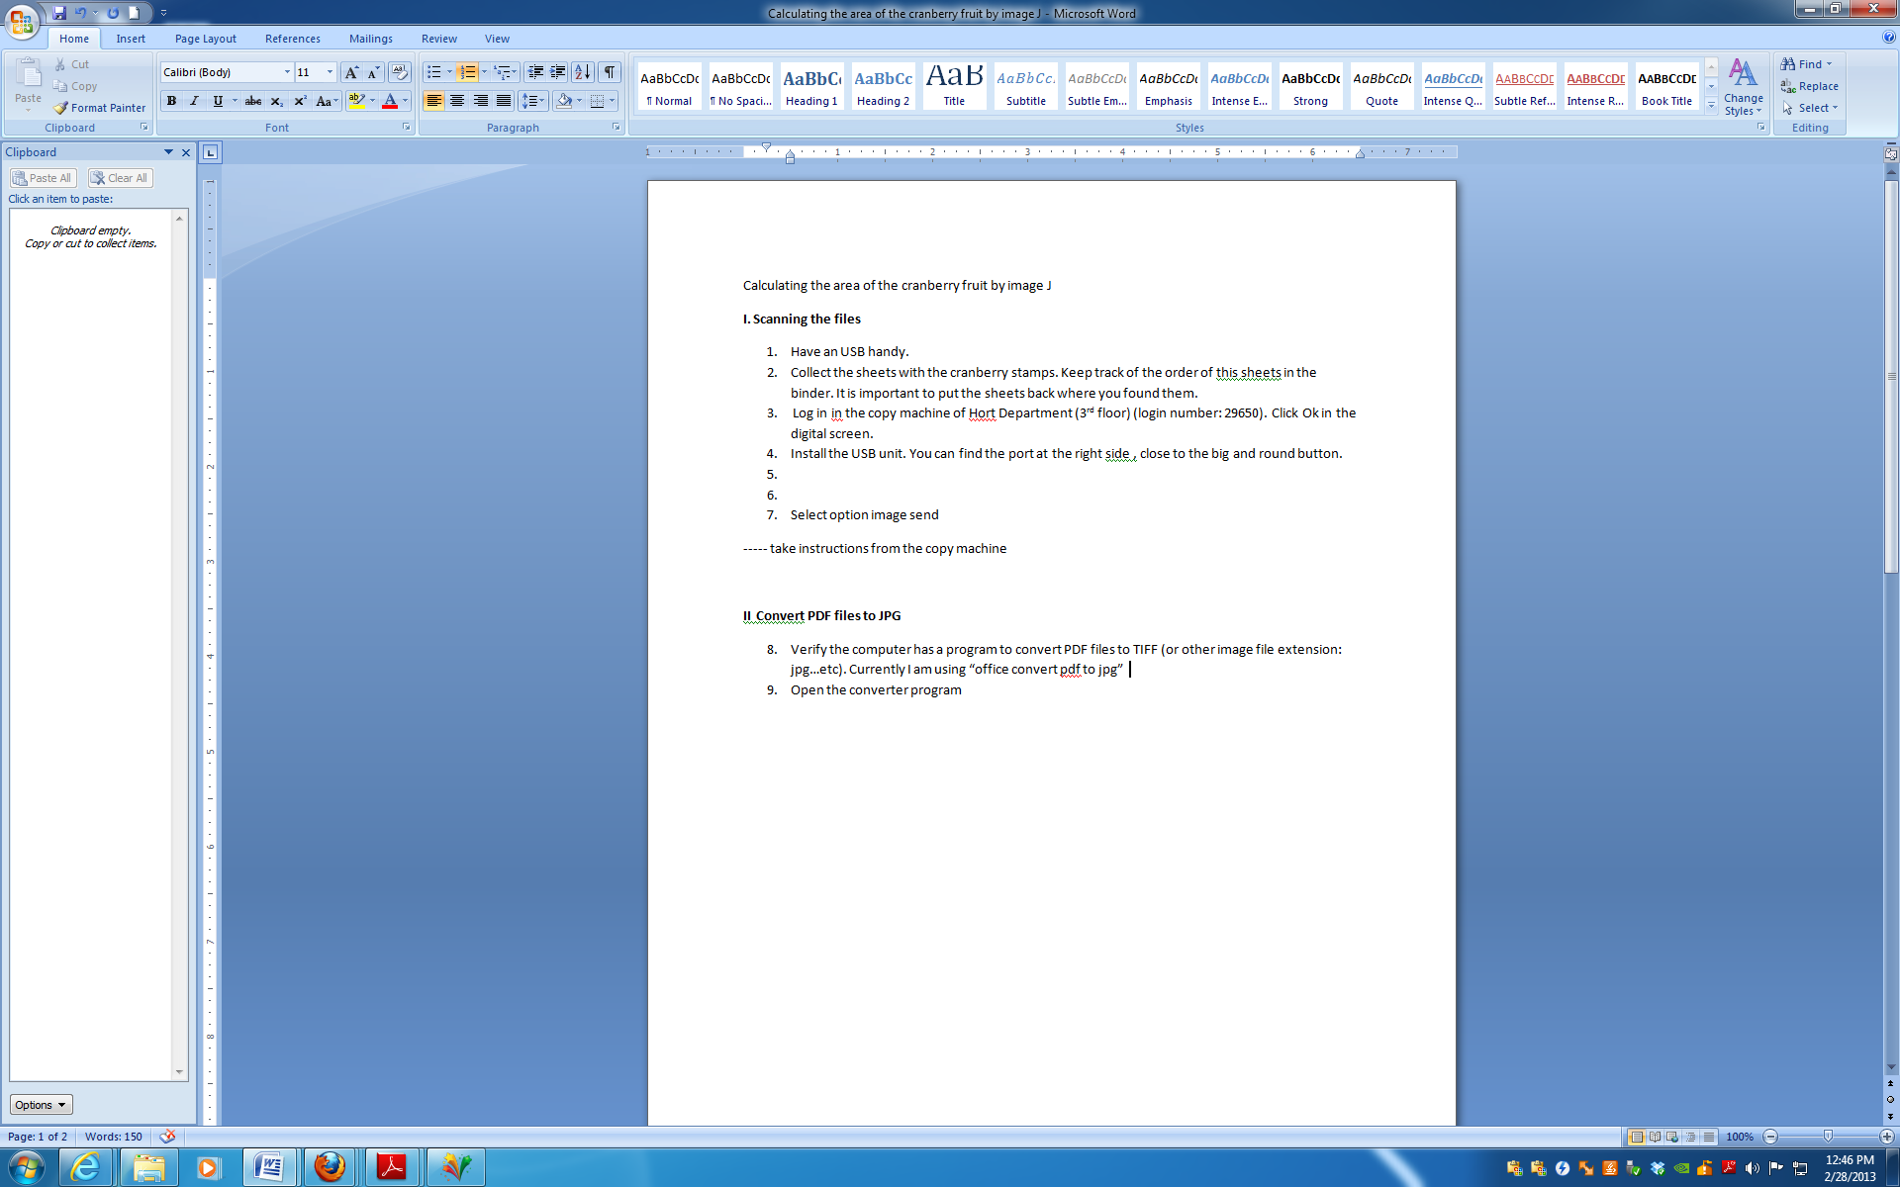Verify the computer has a program to convert PDF files to TIFF (or other image file extension: jpg…etc). Currently I am using “office convert pdf to jpg”
2. Open the converter program

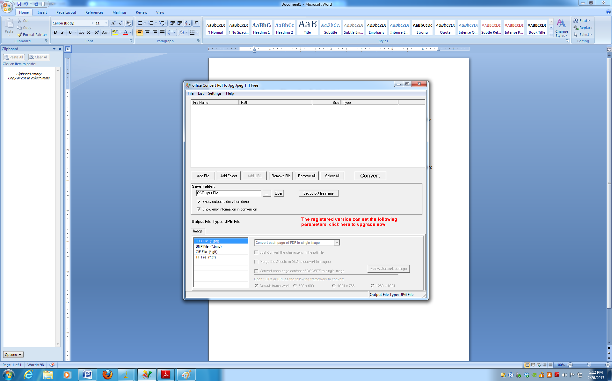

8. in the file menu go to add file and then browse for the name of your file. The file to be converted will appear in the upper part of the window

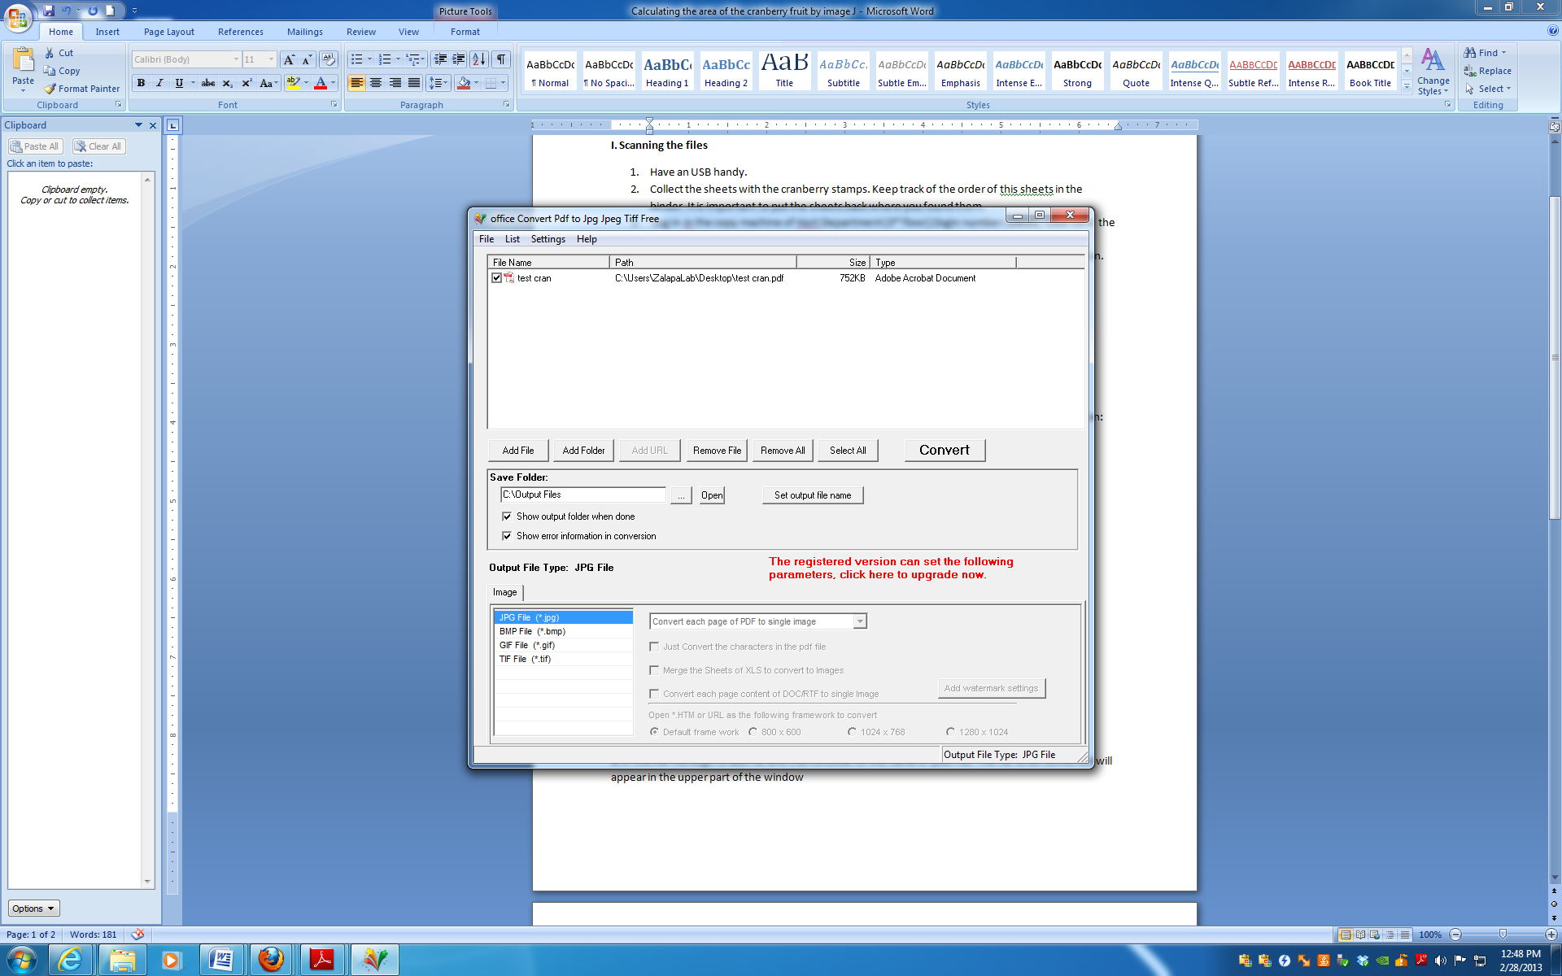

1. In the lower menu you can select the type of file you want your file will be converted to. In this case we can click on jpg



1. Click on convert. It will convert each of the pages of the pdf file into separate files. You need then to rename each of the new files. The program save all of these new files into a folder called “output files” in the disc C (C:\Output Files)
2. Transfer all the files into a subfolder with the year and this under the folder named Cranberry stamps (C:\Users\ZalapaLab\Dropbox\ZalapaLab\NJ Cranberry Samples\Cranberry stamps\2011

**III Image J**

1. Start the ImageJ software
2. Open the file to be analyzed in ImageJ
3. Save the image to a new name so that you do not accidentally overwrite the original image as analyze it.
4. Prepare Image for “Particle Analysis”
   * Convert the image to an 8-bit image
     + Image 🡪 Type🡪8-bit
   * Save the image. One last chance here: ***Make sure you don’t overwrite the original image!***
   * Adjust the threshold for particle detection. Using the menus listed below, adjust the threshold parameters until you have the area of the stamps in red.
     + Image 🡪 Adjust 🡪 Threshold
     + Press Apply.  
       The image should turn black and white.
5. Analyze Particles

The software is going to determine what fraction of the area of this image is black.

* + Set measurement scale.
    - Draw a line over one of the 2 lines outside and close to the name of one of the lines. Then: ***Analyze 🡪 Set Scale***
    - In *Set Scale window* enter 50 into the ‘Known Distance’ box and change the ‘Unit of Measurement’ box to mm. Check ‘Global’
    - Draw a new line on the second line and go to ***Analyze 🡪 Measurement*** to confirm that the measurement scale is correct.
  + Run the analysis
    - With the rectangular selection tool select the stamps of the first 5 uprights of one of the lines. Keep track of the order of the stamps selected. This is important to track and record the areas

test cran-001.tif

Number of the upright

Name of the progeny

Example of one of the sheets with cranberry stamps to be analyzed. Notice that there are 10 boxes per progeny. Each of these boxes contains 2 stamps and a number that corresponds to the upright analyzed. *** important keep track of these number in each of the progeny

test cran-001.tif

Example of the area that need to be selected. Notice that the stamps from the first 5 uprights are selected.

* + - * After selecting the areas go to***: Analyze 🡪 Analyze Particles***
      * Set size as: **50-infinity**. Uncheck pixel units.
      * Circularity: **0.00-1.00**
      * Toggle: **‘Show outlines’**, check **‘ Display results’**. Verify that include holes is NOT checked
      * Click ‘OK’

The output will appear in three new windows. The first is an image in a window called “drawing of *file name*”. The second is a text box that contains numerical results. The third is a second text box called “Summary.”. Study what is in each window carefully to see what information is provided before you continue.

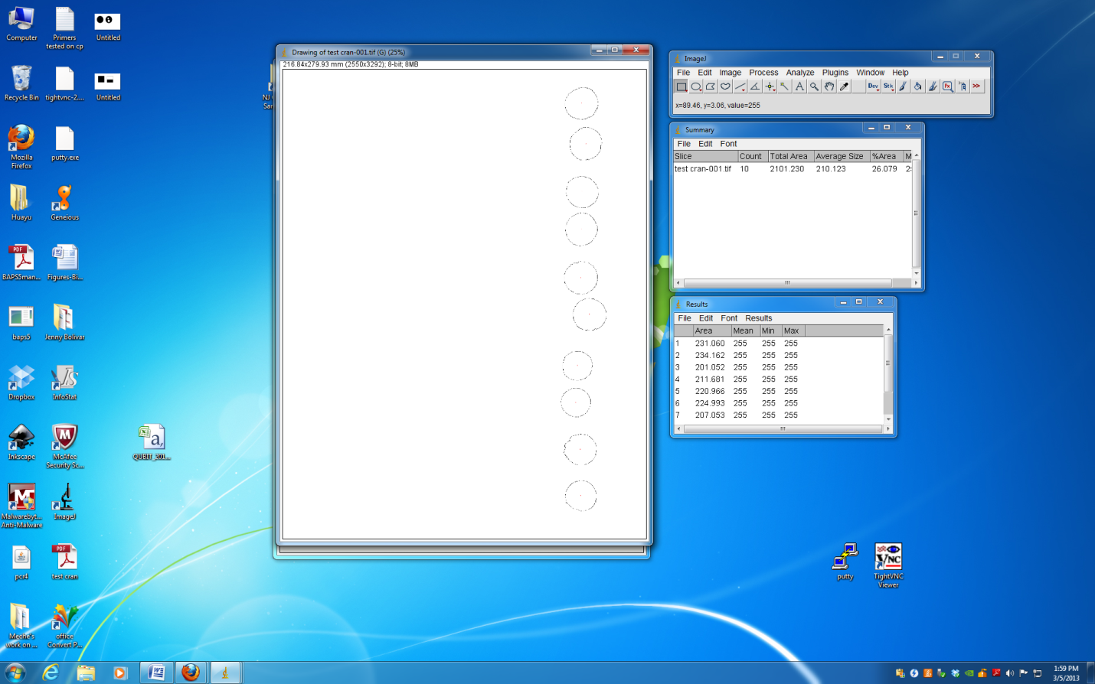

Outline of each of the stamps analyzed.

Each outline has a number which corresponds to the number in the results table

Summary: give you information about the number of samples analyzed and the average area

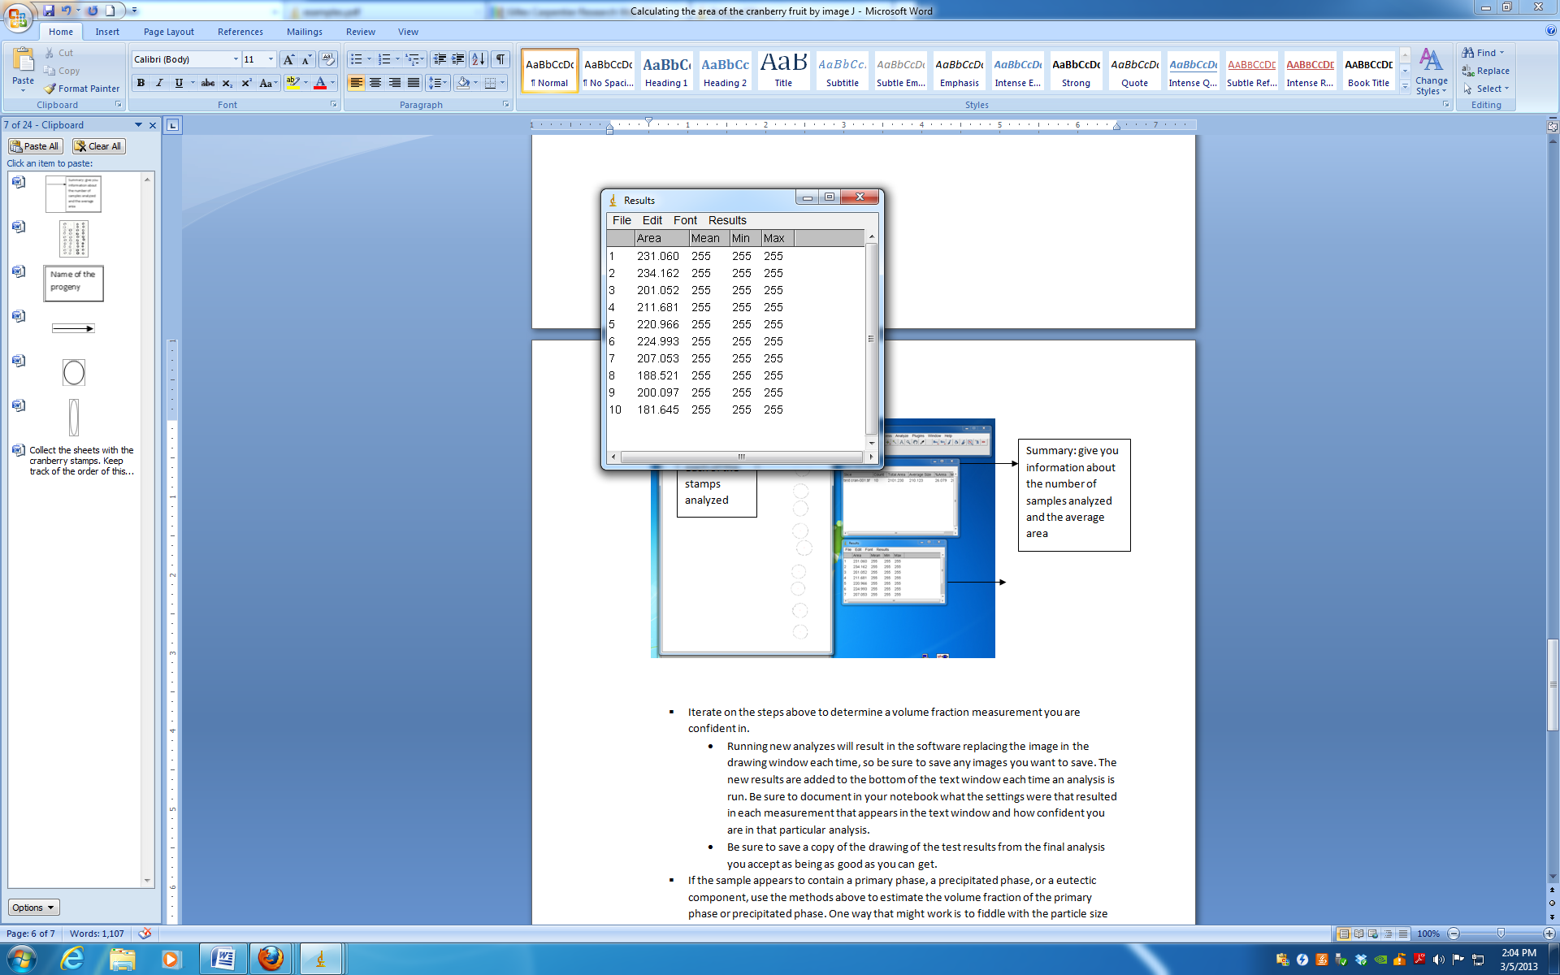

Area of each stamp. Important data

1. In the file: *C:\Users\ZalapaLab\Dropbox\ZalapaLab\NJ Cranberry Samples*  look for the folder and the file where the progeny studied is, and include the area values in the spreadsheet under the column ‘Berry stamp area’. There should be 2 area data per upright number.
   * Note: there won’t be data if the fruit was rotten or the stamp corresponds to a longitudinal section of the berry
2. Repeat from the 5th step to continue measuring the area of the following 5 boxes.